LESCA
Algo1: 1st loop: nb = 1; delta = 2; H = 2; W = 3
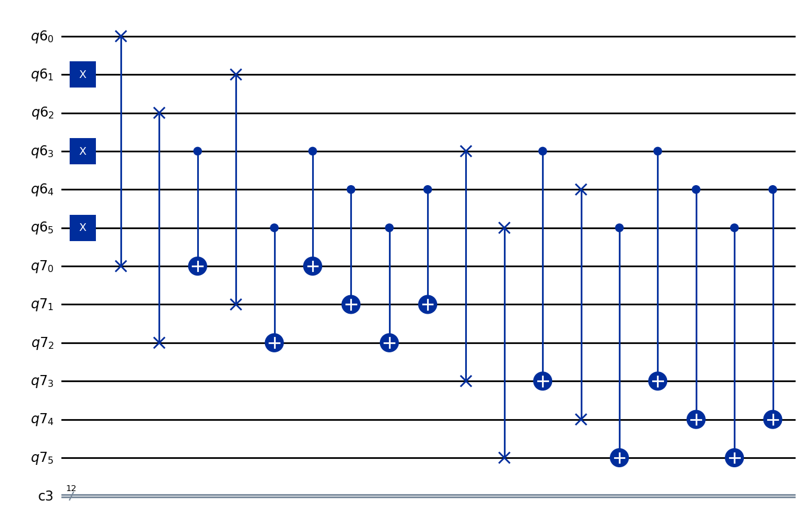
Corrected:
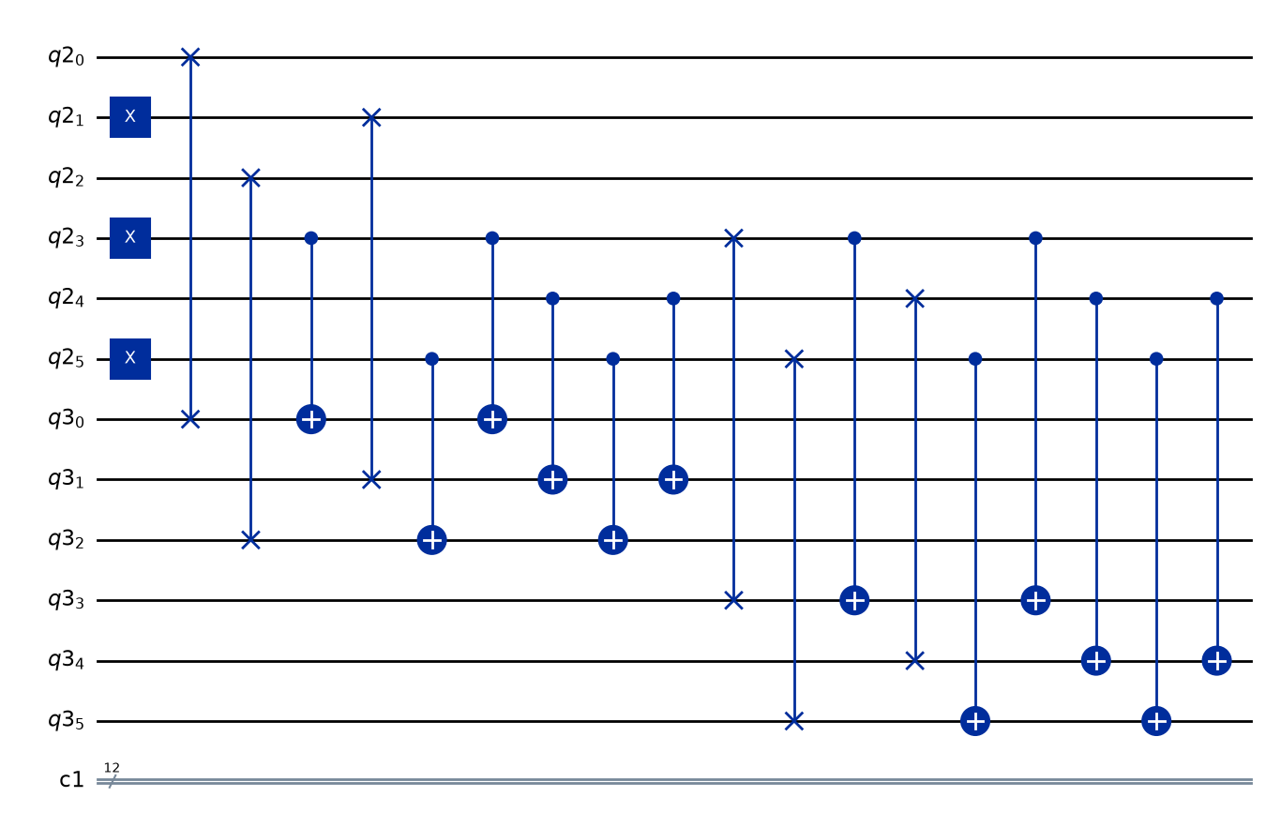
2nd loop: nb = 1; delta = 2; H = 2; W = 3
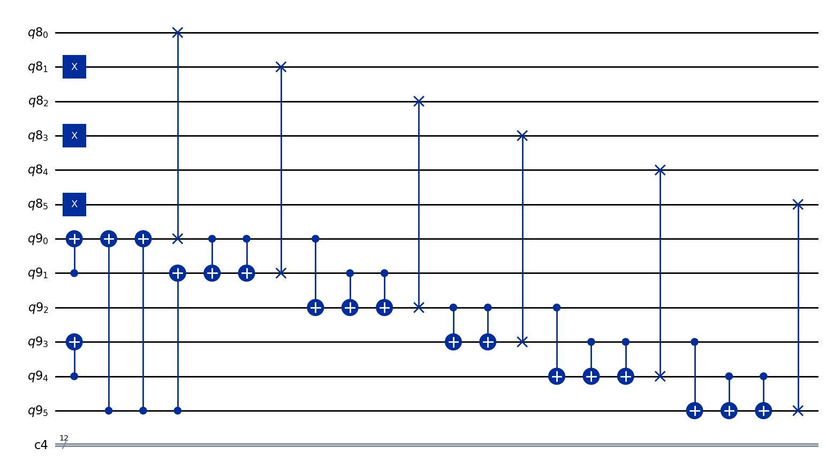
3rd loop: nb = 1; delta = 2; H = 2; W = 3
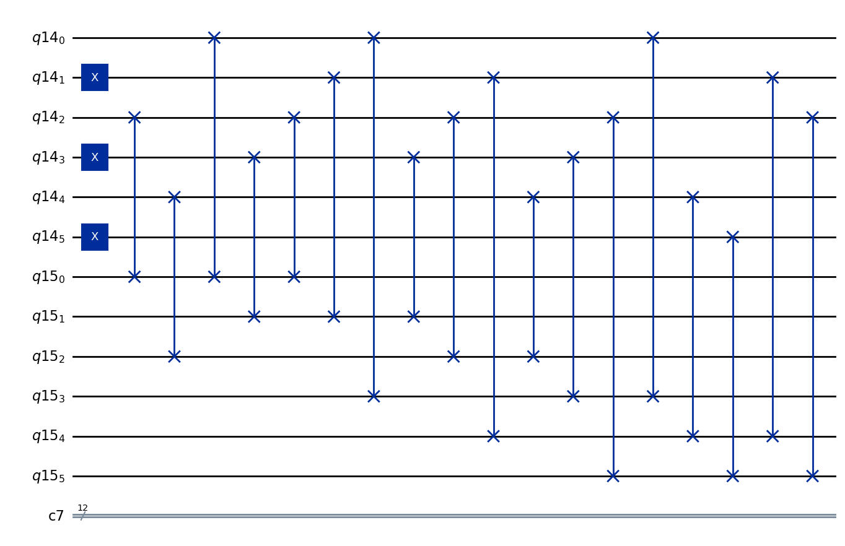
Algo 2: nb = 2; delta = 2; H = 2; W = 3
